According to the Department of Agriculture, Negros Occidental has a 483.37 km coastline and a coastal population of 604,533 across 181 barangays. Twenty-five of the province's 32 local government units are coastal. In 2017, there were 3,650 fish farmers, 31,819 municipal fisherfolks, 2,305 commercial fisherfolks, 2,461 fish processors, and 6,294 fish vendors. Aquaculture includes milkfish, tilapia, prawn/shrimp, snapper, and catfish. Source: OPA, Neg. Occ.

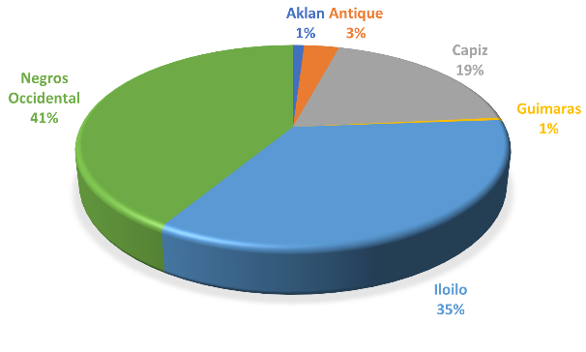

In the area of high value crops, priority commodities of the region such as coconut, cacao, banana, and mango recorded an increase of 0.58 percent, 3.79 percent, 2.21 percent, and 6.51 percent, respectively.  Meanwhile, abaca, sugarcane, watermelon, and vegetables experienced a challenging production performance.

Solon tells DA to prepare quick response fund for drought-hit areas

AGRI Party-list Rep. Wilbert T. Lee said the Department of Agriculture (DA) should be ready to disburse its Quick Response Fund (QRF) provided under the national budget amid the severe drought affecting various parts of the country.

AGRI Party-list Rep. Wilbert T. Lee said the Department of Agriculture (DA) should be ready to disburse its Quick Response Fund (QRF) provided under the national budget amid the severe drought affecting various parts of the country. Lee issued this statement after the declaration of a state of calamity in San Enrique, Negros Occidental following weeks of high temperatures, dry weather conditions, and lack of rainfall. About 90 percent of the town’s rice fields have reportedly dried up already. The lawmaker said farmers couldn’t even start replanting due to the unfavorable weather conditions brought upon by El Niño. At least 20 local government units (LGUs) had earlier declared a state of calamity due to the extreme heat. “Kailangang i-expect natin na sa darating na mga linggo ay madadagdagan pa ang mga lugar na magdedeklara ng state of calamity dahil sa matinding init at tagtuyot,” said Lee. (We have to expect that in the coming weeks, there will be more places that will declare a state of calamity due to extreme heat and drought.)